  
  
  
  
CS 319 - Object-Oriented Software Engineering  
Analysis Report  
  
  
Punch For Glory  
Group 1-C

Taner Baygün

Özgür Can Erdoğan  
Saba Betigül Şahinkaya  
Ömer Berk Uçar

## Introduction

Punch For Glory is a turn based strategy games(TBS) unlike most of the TBS Punch For Glory’s concept is boxing. In TBS category, most of the games are in concept of war and players generally focus on having a strategy to defeat their opponents and make themselves stronger in each battle and eventually they face their nemesis at the end. Main purpose of TBS are defeating all opponents and meet with BOSS at the final stage (Though some games additional game modes other than story).

To give an example punch club has similar understanding of gameplay although there are some differences between them it helps to understanding main concept.([link](http://store.steampowered.com/app/394310/?snr=1_7_7_151_150_1))

In Punch For Glory we mainly focused on developing our games more user-friendly. We are going to simplify some troubles coming from excessive amount of variables in game and more focused on game play.

Objective of Punch For Glory is to beat the BOSS as well as other TBS. To reach main ending of the game player should win the tournament in a month. To progress in game player should register to the tournament. After registration in every 5 days, there is going to be a tournament match by winning those, player can increase his stats and experience. When player reach 2nd position, the player fights with BOSS for winning the game.

The game will be a desktop application and will be controlled by a mouse.

## Overview

Punch For Glory is a TBS where main character is a boxer. Punch For Glory is a TBS where main character is an boxer. Punch for Glory aims to entertain player by developing his very own character and creates very own adventure. While trying to set balance on bank account and trying to prepare next match player sometimes should sacrifice from something and provide other needs. Players ultimate aim is to win the tournament.

## Gameplay

Only required hardware is mouse to play Punch For Glory. Player can choose place which are home, gym, work-office, street ring and tournament arena on map. In places several actions can be found. Time for player will be shown at the right top, player can follow period of day from there. When player click on actions, its corresponding results will blink on screen. Green numbers will show how a stats, money, or experience increase. Red numbers will show when the player lose his stats, money, or experience. In matches, there is going to be different menu for using pre-determined skills. On that screen, the Player can determine which skills to use.

## Levelling

There are 2 leveling systems in game. 1st one is to character development. As our character trains, he increases his stats, also, he increases his experience after doing trainings and matches. By increasing his experience player can unlock new skills. 2nd levelling is the one in tournament. To end the game player have to reach 2nd place. Our character start from worst rank and by defeating his opponents he can rank-up. In God mode which is difficulty level, If he loses then he plays with the opponent under him, if player lose against the one who has less rank rank-down. When player reaches 2nd rank he earns right to fight against boss.

## Places

There are 5 places in game those are workplace, arena, gym, street ring and home. Workplace is to having solid income it does not have any risk but income is not much. Arena is a place where boxers fight in order to increase their position in the league. Gym is to work out and improve Player’s stats. Street ring is an alternative fighting mode to arena, player can fight anytime in streets and income is more compare to workplace but it is riskier because there is no guarantee to win these matches. In street ring, sides can use baseball bat, knife etc. Therefore, it is more likely to injured in streets rather than arena. Home is a place where the boxer can rest and end the day. There is no danger in home but player have to afford paying the rent to have home otherwise he kicked out of house and to get move in again he has to pay re-open money.

## Items

There are some wearable items in game. Items brings extra stats. Gloves and shorts can be use in any match but weapons can only use in streets. In gloves and shorts color of them determine their extra stats, in weapons there are sharp and blunt weapons. Sharp weapons have more damage while hard to hit with blunts are less damage but easier to attack with.

## Character

In Punch For Glory characters are stickmen. Enemies vary in colors each has its specific color. Player can choose main characters’ color in login screen. To distinguish boxers, stickman’s color, glove colors or short colors are used.

1. **Requirement Specification**

**3.1 Functional Requirements**

**3.1.1 Play Game**

Glory for Punch is a kind of an arcade game. The main purpose of the game is beating other boxes in the league and become champion. At the beginning of the game, Player chooses difficulty level which are Normal and God Mode. After that, the player chooses his boxer’s fighting style which are tank, butterfly, hammer. Depending of the Player’s choose his boxer starts the game with little advantages which is increasing his stats little bit. Tank increases his health. Butterfly increases his agility. Hammer increases his attack’s damage.

In Normal mode and God mode, after choosing his fighting style, Player enters the league. His first challenge is fighting against the best boxer in the league. This first match is absolute lose which indicates the Player must train his boxer in the gym by selecting different type of trainings which have different results on boxer’s stats. After completing some trainings, boxer starts to glorify his career by fighting with other boxers in the league. The player starts the league at the bottom, and he tries to increase his position in the league by beating his opponents. In order to win the game, the Player has to beat the best player. If the Player loses the final match, he loses the game. Otherwise, he wins the game.

Winning matches grant some money for paying his apartment’s rent and gym’s rent. However, winning matches won’t grant enough money to live. The player must work or fight in illegal box matches to earn money. Also, the Player can purchase some power ups with his money. These power ups and illegal box matches makes game much more challenging and enjoyable. Also, The Player has only 3 move options in a day. He should choose his actions strategically to win the game smoothly.

In Normal mode, losing a match has no penalty to the player. However, in the God mode, losing consecutive matches causes to lose the game.

**3.1.2 Change Settings**

Player can change some of the game settings according to his wishes. The settings that can be changed by The Player are listed below:

* Sound On/Off.
* The appearance of his boxer.

**3.1.3 Pause Game**

The game can be paused during box matches. Then, the player can continue the match where he paused. However, closing the application causes to lose all the progress.

**3.1.4 View Help**

The player can get all the information about the game in that section. This information mainly aims to show purpose of the game, difference between Normal mode and God mode. Also, shows the controllers of the game.

The information that will be shown:

* Main purpose of the game
* Difference between Normal mode and God mode
* Controllers

**3.1.5 View Credits**

Player can reach information about the game’s developers. Also, it has a contact information. By using this information, the Player can communicate with the developers to help the development of the game in the future.

**3.1.6 Mode Settings**

Player can set the difficulty level, before the game starts. There are two difficulty levels which are listed below:

* God mode
* Normal mode

Also, the Player can set his fighting style, before the game starts. There are three fighting classes which are listed below:

* Tank
* Butterfly
* Hammer

**3.2 Non-Functional Requirements**

**3.2.1 Game Performance**

The smoothness of the game is one of the most important features. While fighting, or going somewhere on the map, game should not wait player because of decrease in its response time or frozen totally. We will make the game run smoothly every part of the game even when boxers use animations in a fight. The game will run in high smoothness and performance through the gameplay.

**3.2.2 Wide Range Skills**

In a fighting game, different actions in fights increase playability of the game. Also, rich skill list offers more fun to users while playing, also, lead different tactics and attack types. Therefore, we will develop a game has a wide choice of skills in skill list. We will show rich list of fighting skills for the Player’s, so the Player can develop different fighting tactics and attack combinations. These skills will be included kicks, punches, and even some other parts of the body attacks.

**3.2.3 Interface**

We will build an user-friendly interface which provides users to understand how to play easily, and not confused them by complicated options or features in the interface. The main purpose of our interface is will ensure that people who do not even know using computer very well can play our game easily. The instructions will be clear and simple. Therefore, interface of the game will provide user-friendly game environment.

**3.2.4 Extendibility**

The game has a developable foundation. There are lots of ways and points can be improved and extended for later updates. For example, different maps or storylines can be added to the game later on. We will also design the game to be easily extended later.

**4. System Model**

**4.1 Use Case Model**

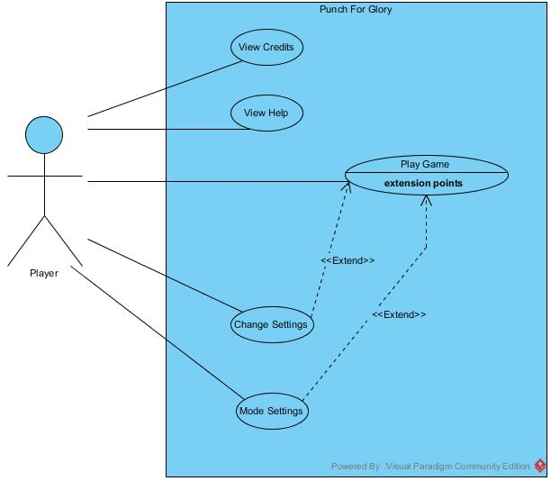

**4.1.1 Play Game**

**Use Case Name: Play Game**

**Primary Actor:** Player

**Stakeholders and Interests:**

* Player aims to win the league.
* System keeps the Player’s stats, experience, money and place in the league.

Pre-condition: Games starts with default difficulty mode and fighting class. Player can change difficulty mode and fighting class before game starts. These changes will be saved for the rest of the game.

Post-condition: If Player increases his stats, experience, money and place in the league, these will be updated by the system.

Entry Condition: Player selects “Start Game” button from Main Menu.

Exit Condition: Player selects “Back to Main Menu” from Pause Menu.

**Success Scenario Event Flow:**   
1. Player starts the game.  
2. Player starts playing from base stats of fighting class and default money and experience.  
3. Player plays until win against his next position opponent in the league.  
4. System increases the place of the Player in the league.  
5. Player again starts playing until win against his next position opponent in the league.

*Player repeats the steps 3 – 5 until win the league.*

6. System shows congratulations message.

7. System returns to Main Menu.

**Failure Scenario Event Flow:**

1. Player starts the game.  
2. Player starts playing from base stats of fighting class and default money and experience.  
3. Player plays until win against his next position opponent in the league.  
4. System increases the place of the Player in the league.  
5. Player again starts playing until win against his next position opponent in the league.

*Player repeats the steps 3 – 5 until lose against the rank 1 opponent or in God mode, loses two consecutive matches*

6. System shows failure message.

7. System returns to Main Menu.

**Alternative Flows:**  
3A. Player plays until win against his next position opponent in the league.  
 3A.1. Boxer train himself in the Gym until has enough stats to face with the next opponent.  
 3A.2. Boxer chooses his skills from skill list.  
 3A.3. Two boxers use their skills to decrease opponent’s health.  
 3A.4. The boxer whose health becomes zero will lose the match  
 3A.5. If the Player’s boxer wins the match, place of the boxer in the league will be increased

3B. Player can earn money during game and buy power ups:

3B.1. Boxer goes to work to earn money or Boxer earn money after fights.

- *This step can be repeated many times.*  
3B.2. System stores the total money of the Boxer.  
3B.2. Player can buy power up(s).  
3B.3. Power up(s) which is bought by Player will be added to the Boxer’s inventory.

3B.4. Player can change his inventory by buying new power up(s).  
3B.5. If Player buys new power up(s), System deletes the weaker power up(s) from his inventory.

1. If player requests to pause the game at any time during the box matches:  
   A.1. Player clicks pause button on the screen.  
   A.2. System pauses the game.  
   A.3. System continuous when the Player clicks the pause button again.

**4.1.1.1 Healing**

**Use Case Name: Healing**

**Primary Actor:** Player

**Stakeholders and Interests:**

- After the matches and boxer’s health is low, Player wants to heal boxer.

**Pre-condition:** Player has to be in map screen.

**Post-condition:** Boxer will heal.

**Entry Condition:** Player click on house icon on the map.

**Exit Condition:** Player click on return button on house frame.

**Success Scenario Event Flow:**

1. Player click on house icon on the map.

2. System shows house screen which indicates boxer goes to the house.

3. Player click on sleep button at the bottom.

4. System updates health of the boxer.

**Alternative Flows:**

A. When Player wants returning to map from house:

A.1. Player presses “return to map” button in house screen.

A.2. System close house frame and show map screen.

**4.1.1.2 Increase Stats**

**Use Case Name: Increase Stats**

**Primary Actor:** Player

**Stakeholders and Interests:**

- To win against next opponents Player wants to increase boxer’s stats.

**Pre-condition:** Player has to be in map screen.

**Post-condition:** Boxer’s stat(s) will increase.

**Entry Condition:** Player click on gym icon on the map.

**Exit Condition:** Player click on return button on gym frame.

**Success Scenario Event Flow:**

1. Player click on gym icon on the map.

2. System shows gym screen which indicates boxer goes into the gym.

3. Player click on any machine to work out.

4. After workout finished system updates stat(s) of the boxer.

**Alternative Flows:**

A. When Player wants returning to map from house:

A.1. Player presses “return to map” button in house screen.

A.2. System close house frame and show map screen.

B. When Player wants to increase stat(s) without workout:

B.1. Player click on the store button.

B.2 System shows the store screen.

B.3 Player buys items if he has enough money for them.

B.4 System add item boxer’s inventory and update boxer’s stat(s).

**4.1.1.3 Fight in Match**

**Use Case Name:** Fight in Match

**Primary Actor:** Player

**Stakeholders and Interests:**

- Player wants to fight against his opponents.

**Pre-condition:**

**-** Player has to be in map screen.

- It should be match day.

**Post-condition:** Player’s abilities and game will update according to match result.

**Entry Condition:** Player click on arena icon on the map.

**Exit Condition:** Player click on return button on arena frame.

**Success Scenario Event Flow:**

1. Player click on arena icon on the map.

2. System shows arena screen which indicates boxer enter the arena.

3. Player click on fight button.

4. Player choose skills to use in fight and click on fight button.

5. Player’s boxer and opponent showed on the screen.

**Alternative Flows:**

A. If there is not arena match and Player wants to fight:

A.1. Player click on the street icon on the map.

A.2. System automatically choose opponent among street fighters.

**4.1.2 View Credits**

**Use Case Name: View Credits**

**Primary Actor:** Player

**Stakeholders and Interest:**

- User aim to reach the text panel which contains contact information of game developers.

**Pre-conditions:** User should be in main menu.

**Post-conditions**: -

**Entry Condition:** User presses the “Credit” button in main menu.

**Exit Condition:** User presses the “Back” button to return main menu.

**Success Scenario Event Flow:**

1. System shows text frame which contains contact information of the developers.

**Alternative Flows:**

A. If user wants returning to main menu:

A.1. User presses the “Back” button to return main menu.

A.2. System displays main menu.

**4.1.3 Change Settings**

**Use Case Name: Change Settings**

**Primary Actor:** Player

**Stakeholders and Interests:**

- Player wants to change game settings which are sound setting and appearance of the boxer.

- System saves the changes.

**Pre-condition:** At the first opening of the game, system makes settings as default. After changes are done, system updates new version of settings.

Post-condition: Game settings are updated.

Entry Condition: Player presses “Settings” button in main menu.

Exit Condition: Player presses “Back” button to return main menu.

**Success Scenario Event Flow:**

1. Player selects “Settings” button and reaches the game settings panel.

2. Player can change game settings.

3. System updates the changes.

**Alternative Flows:**

A. If Player wants returning to main menu:

A.1. Player presses “Back” button on settings screen.

A.2. System updates the changes.

A.3. Player returns to the main menu.

**4.1.4 Mode Settings**

**Use Case Name: Mode settings**

**Primary Actor:** Player

**Stakeholders and Interests:**

- Player wants to choose game mode, and the boxer’s fighting class.

- System offers “Normal Mode” and “God Mode” as difficulty level.

- Player can select either “Tank”, “Butterfly”, or “Hammer” as the fighting class of the boxer.

**Pre-condition:** At the first enter to game, mode and class are chosen as default values. When Player makes changes, system will update these settings.

**Post-condition:** Game mode and fighting class settings are updated.

**Entry Condition:** Player presses “Mode” button in main menu.

**Exit Condition:** Player presses “Back” button in mode screen.

**Success Scenario Event Flow:**

1. Player presses “Mode” button in main menu.

2. Game mode and fighting class settings are showed as multiple choices.

3. Player chooses one of the choices.

4. System updates game mode and fighting class settings.

**Alternative Flows:**

A. When Player wants returning to main menu:

A.1. Player presses “Back” button in mode screen.

A.2. System updates game mode and fighting class settings.

A.3. Player returns to main menu.

**4.2 Dynamic Models**

This section provides detailed information about the Punch For Glory game by showing some important scenarios of the game in sequence diagrams.

**4.2.1. Sequence Diagrams**

**4.2.1.1. Play Game**

**Scenario:** Player Emrah requests to play game by pressing proper button from Main Menu. After that, System initializes the game and load them to screen. Then, system loads the map of the game. After that, Emrah has to play with the best player of that league in order to join the league. System waits for Emrah’s decision for that match. After accepting the match, System loads the arena and match starts. Emrah and his opponent apply their skills in their turns. If Emrah wants to apply skill during his opponent’s phase, System warns it’s in cooldown period. After the match, System shows the result of the match and Emrah starts his journey.

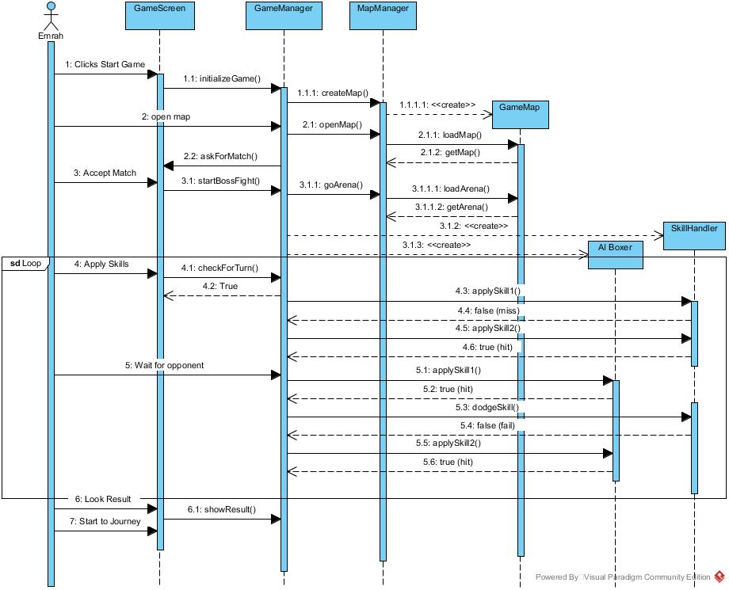

**4.2.1.2. Power up Management**

Following sequence Diagram illustrates the scenario explained below:

**\*** We assume it is understood how play game, therefore a normal day passing. In this part we are going to try explain the how power-up works in background of the game.

**Scenario:** Player Cengiz at the 6th day of the game has enough money to buy some equipments therefore he decides to go to shop. He buys one blue gloves, one red gloves, and a knife. Then he equips red boots instead of blue ones(which is currently wearing). That part take place in “day loop” if it is performed it is not an additional loop. If a legal item bought and that kind of item will be worn at the moment game automatically, if item is illegal it doesn’t.

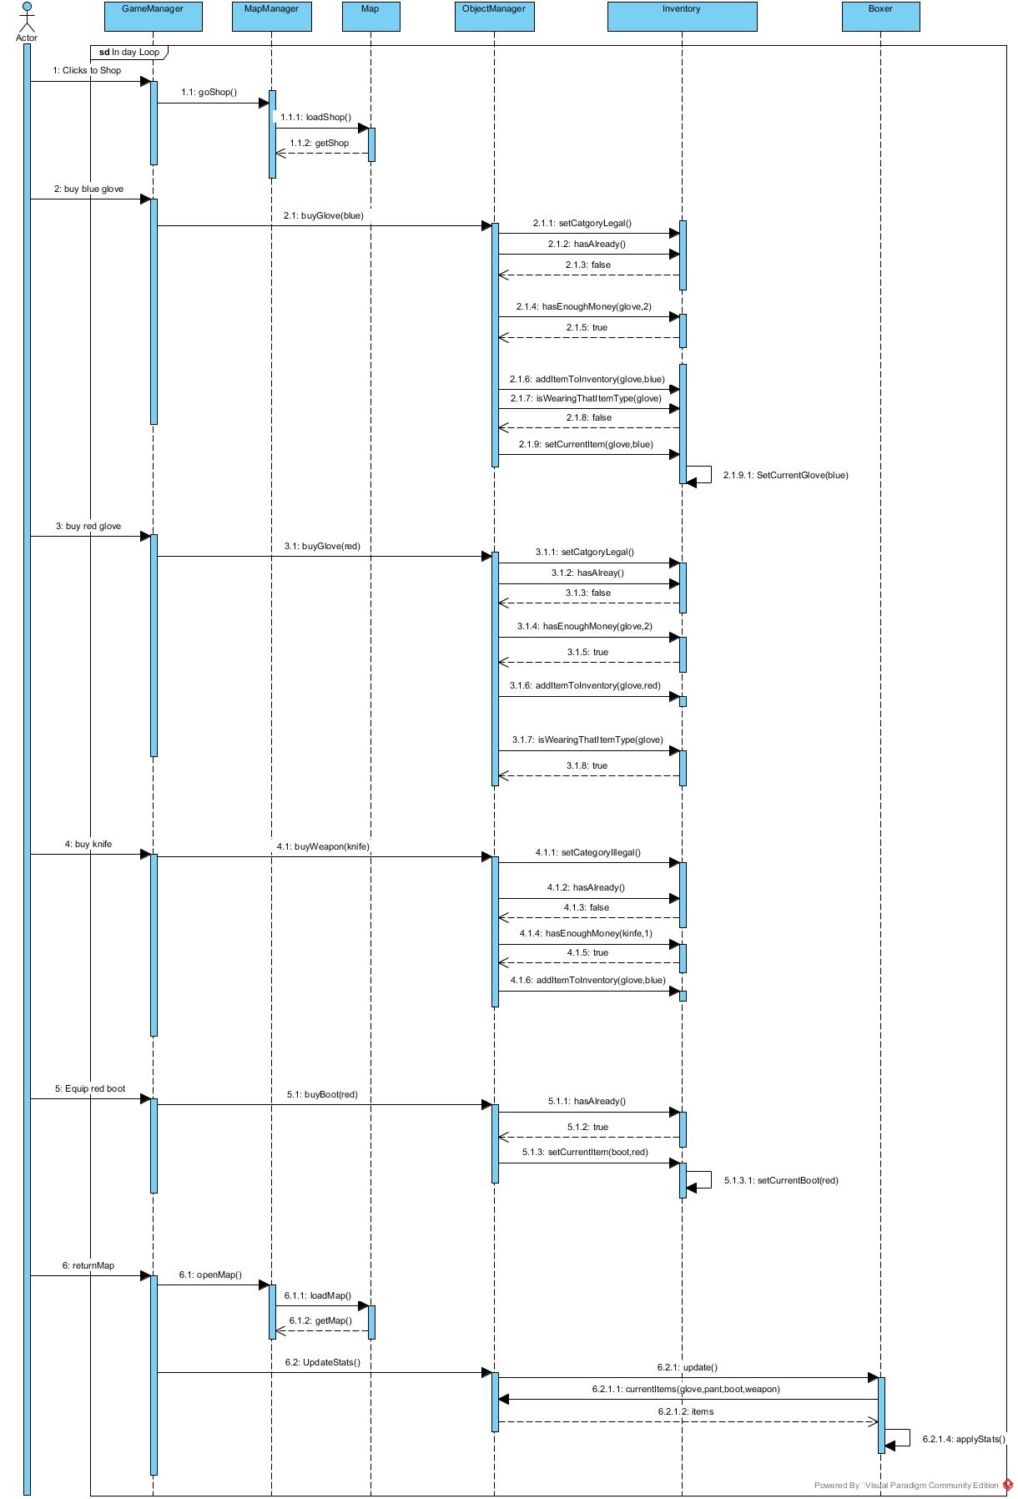

**4.2.1.3. Change Settings**

**Scenario:** Player Cengiz desires to change the game settings, before the game initialized. He presses change settings button from the Main Menu. System displays the settings, and he can change the settings. After that, System updates the new settings.

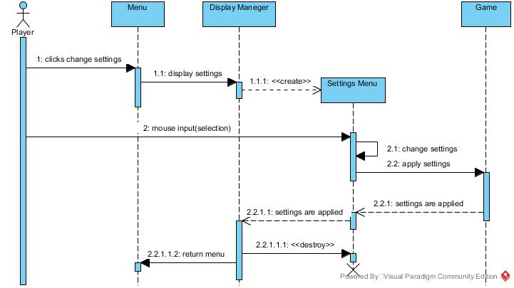

**4.2.1.4. Change Mode Settings**

**Scenario:** Player Cengiz desires to change the mode settings, before the game initialized. He presses change settings button from the Main Menu. System displays the settings, and he can change the settings. After that, System updates the new settings.

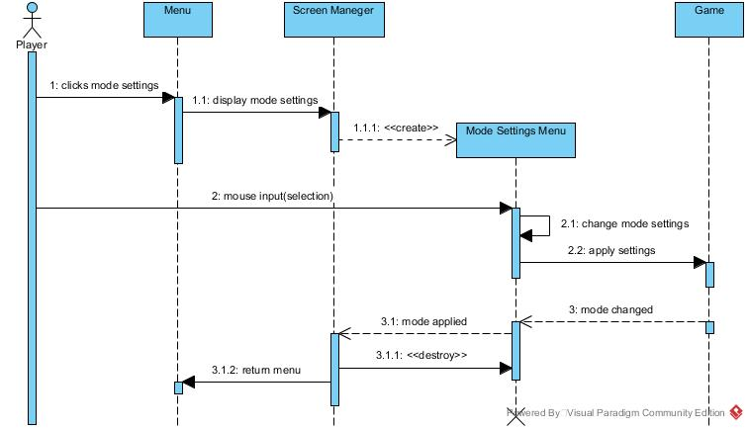

**4.2.2. Activity Diagram**

This diagram shows how system maintains the gameplay.

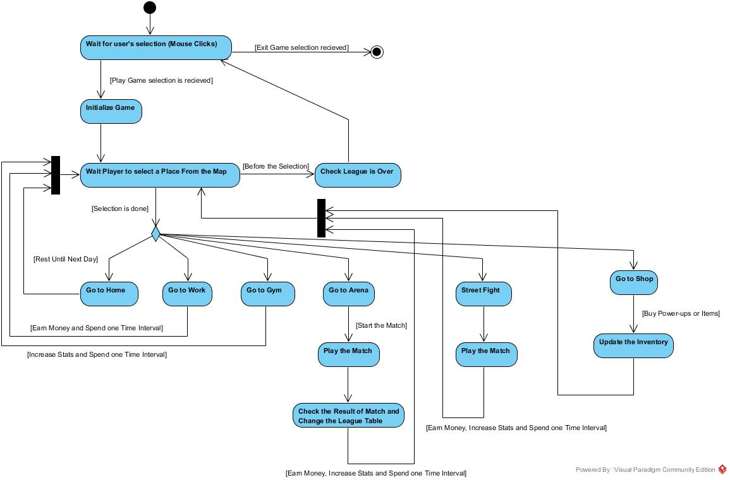

When user select Play Game selection, system initialize the game, game objects and game map. When this process is finished, system waits user’s selection at the map by using mouse clicks. System will provide 6 map locations to the user. User selects one of them. System will observe the selection and it will go to proper map location. If the user goes to home, he will be rest until next day and heal himself, therefore, he cannot do other actions. If he selects to go work, he will spend one time period and he will earn money to buy items and pay rent. Also, user can go to gym to increase his stats, but this action costs one time period too. Going to shop has no time cost, but user has to pay.

Going to Arena and Street Fights have some common aspects. Both require one time period to complete that action and both will help to increase boxer to increase his stats. If the user wins the league match, system will change the league table. After changing the league table, system will check the user’s position at the league. If he is at the top of the league, system finishes the game, otherwise, user continue to play game.

**4.3 Object and Class Model**

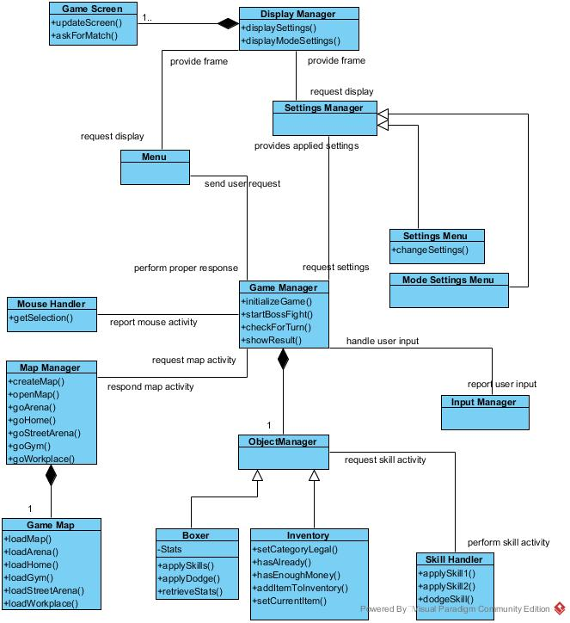

The object model of Punch For Glory is illustrated above. There are 15 classes in diagram.

Manager classes of the system has the task of organizing the game. Manager classes explained briefly below:

* **Game Manager** is the main controller of the game system. It cooperate with other manager classes and organize game dynamics.
* **Object Manager** is the main controller of the objects in the game. It cooperates with Game Manager and handle object issues.
* **Map Manager** is the controller of the maps. It cooperates with Game Manager, creates maps and handle “go” operations. It creates Game Map class and control it.
* **Input Manager** get inputs and report them to Game Manager.
* **Setting Manager** is parent class of Settings Menu and Mode Settings Menu and organize these two setting menu. It cooperates with Display Manager and Game Manager.
* **Display Manager** organize display issues. It cooperates with Game Manager and control over display operations.

We have Boxer and Inventory classes which are children of the Object Manager. In Boxer class, we store boxer object information and handle its operations. Both player’s boxer and AI boxers are included in this class. Inventory class store item information on the boxer and item related operations.

Skill Handler class cooperates with Game Manager and handle all fight skill related operations like using skill or dodge them.

Mouse Handler is used when User choose option with mouse click. It cooperates with Game Manager and send user request.

Game Screen class is created by Display Manager and in charge of updating screens. It manages changing different frames properly.

**5. User Interface**

*Note: These Images are not finalized and not showing full content. These are just demos.*

**5.2 Main Menu**

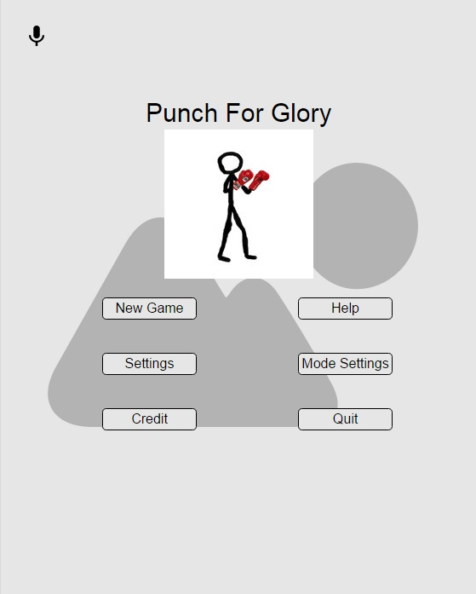

Main menu has a simple outline. It has only 5 buttons which are “Play Game, Settings, Help, Credits, Game Mode, and Exit”.

**Start Game:** Button for starting the game. It leads another panel which user will chose game mod.

**Setting:** This button leads the game options. Settings panel include sound control, appearance control. User will be able to open, close, and adjust sound level in sound control part. User will change the outfit of the player’s boxer. This is only changing in appearance so it does not affect gameplay or level of character.

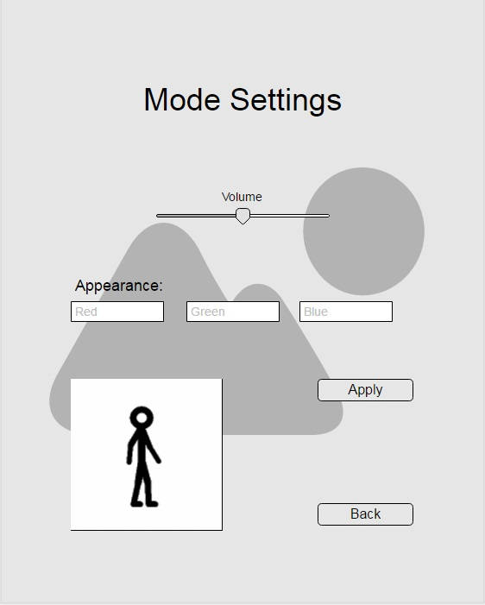

**Help:** This button open a text panel which explain game controls. It shows which buttons can be used and what they are used for with a detailed explanation.

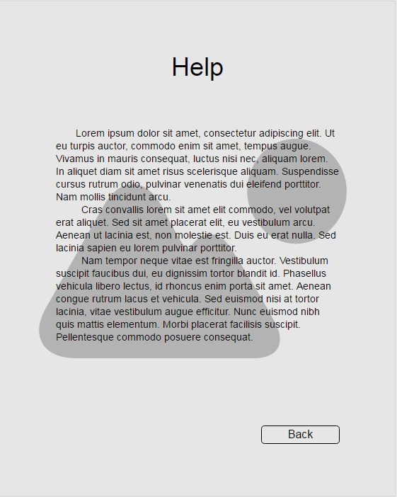

**Credits:** This button leads a text panel which contains information of game developers.

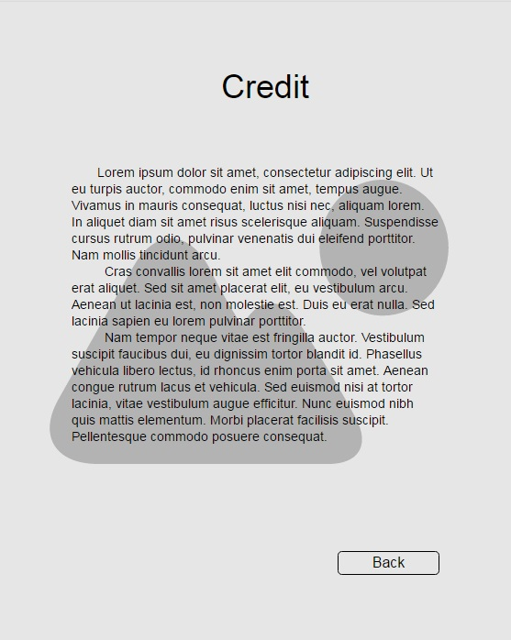

**Mode Selection:** This button leads the modes of game. There are two difficulty levels.

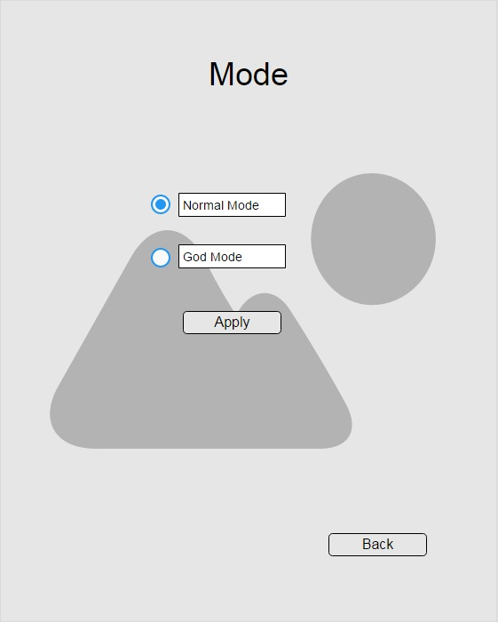

**Quit:** Button for exit the game.

**5.3 Map**

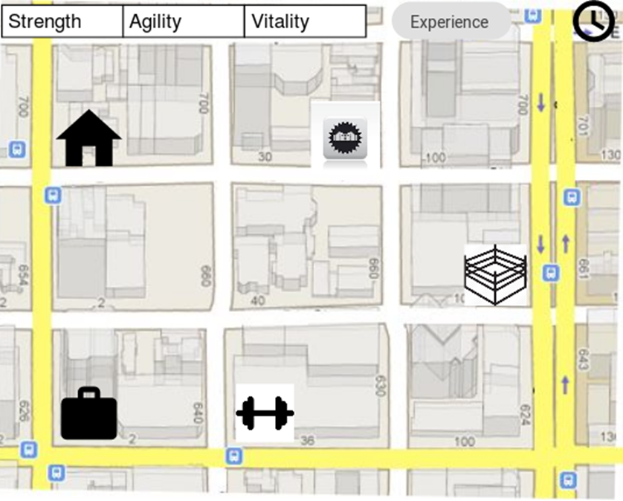

Map shows the all visitable places in the game. Player can see the place icons in the map which are home, gym, work, box ring, and street ring. Player click on the icon which place he wants to go, then Player’s boxer will go to the chosen place. Each place has specific purpose in the game.

**Home**: After the end of the day, Player’s boxer should rest. Home is the place where boxer can rest and be ready for next day.

**Gym:** Between fights boxer need to train himself. Gym is the place where Player’s boxer trains himself and increase his experience and stats.

**Work**: Money is important for paying gym and house rents, and also, buying items. Although after winning matches Player earn money, it will not enough. Therefore, Player should make his boxer work and earn money. Work is the place boxer earn money for different necessities.

**Arena**: This place is where legal tournament fights are going on. Main purpose of the game is winning this tournament in the Arena. Therefore, Player will fight in Arena on fixed dates.

**Street Ring**: Unlike Arena, Street is where Player can fight illegally for earning some experience or money. Since it is not tournament fight, it will not affect Arena fights or cause Game Over (in God Mode).

At the top of map GUI stats and experience of boxer will be shown. Therefore Player can check boxer’s attributes on map too. Also time will be shown on the map so Player can follow the time while changing place.

**5.3.1 Home**

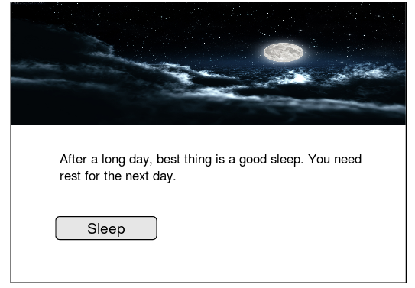Graphical interface of home frame is simple. It includes a text and the sleep button which activates sleep action.

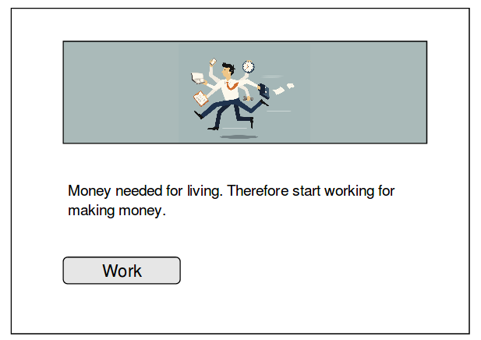**5.3.2 Work**

Graphical interface of work is simple. It contains a text and a work button which activates work action.

**5.3.3 GYM**

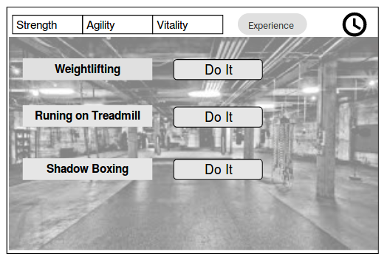

We have a simple gym frame. It consists of three work option which increased different stats. Also, Player can see boxer’s stats, experience and time inside the gym. For each workout option, we see a “Do It” button indicates doing that workout.

**5.3.3 Arena and Street Fight**

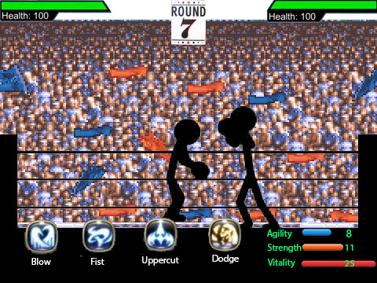

**6. Conclusion**

In this report, we prepare analysis report part of the project. This is the first step of the project which will be followed by design and implementation. Analysis report has two main parts, requirement specification and system model.

In requirement specification part, we aim to organize all requirements for our game. Both in functional and non-functional requirements we try to find all possible requirements and analyze them in details. Our main purpose is analyzing the requirements as detailed as possible so that create a system model better.

Second main part of our project is system model. System model consist of four parts:

1.Use case model

2. Dynamic models

3. Class model

4. User interface

In use case model, we thought on possible actions in the game and generate use cases from them. When we were generating use case model, we specified requirements and possible outcomes of actions in use cases.

In dynamic model, we have two parts which are sequence diagrams and activity diagram. We tried to find all possible important actions and interactions between system and player. We used these actions and interactions as base of our sequence diagrams. After decided on sequence diagrams we create activity diagram which show how system maintains a gameplay. It explains our gameplay design simply.

In class model, we identify classes we will use in the game. We decided on their relations and interactions, also their methods which are also used in sequence diagrams.

In user interface, we designed the frames will be used in the game. We aim making user interface as simple as possible. Also, we created a navigational path with using our use cases.

To conclude, we tried to make analysis report as best we can do because we will use it as a base of our design and implementation tasks.